NOTICE OF PUBLIC HEARING

Alpine County Board of Supervisors

Tuesday July 16, 2024 10:00 AM

Alpine County Government Center – Board Chambers

99 Water Street

Markleeville, California

PLANNING COMMISSION APPEAL

Notice is hereby given that the Alpine County Board of Supervisors will conduct a public hearing regarding an appeal filed on the Alpine County Planning Commission decision of May 30, 2024 denying a conditional use permit for an Expanded Home Occupation (18.70.120) to operate an outdoor/indoor event venue from the home located at 155 Blue Camas Road, including the finding that the project is categorically exempt from the California Environmental Policy Act (CEQA) pursuant to Section 15304 (e), Minor Alterations to Land, Temporary use of land having negligible or no permanent effects on the environment, including carnivals, sales of Christmas trees etc.. (Applicant: David and Jean Vandenberg – Owner, Aspen Creek Lodge; Planning Case File #2024-022)

The public hearing will be held during the regular meeting of the Alpine County Board of Supervisors on July 16, 2024 at 10:00 AM, or as soon thereafter as the matter can be heard, at the Alpine County Government Center, Board Chambers, 99 Water St, Markleeville, California.

Members of the public are invited to attend the public hearing, and if desired, may be heard regarding the appeal. Written comments to be included in the administrative record of the proceedings may be e-mailed to clerk@alpinecountyca.gov or mailed to:

ALPINE COUNTY CLERK
P.O. BOX 158
MARKLEEVILLE, CA 96120

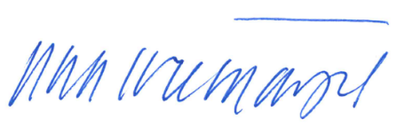

DATED: June 25, 2024
__________________________________
TEOLA L. TREMAYNE, County Clerk and
Ex officio Clerk of the Board of Supervisors, County of Alpine, State of California

